Project Planning Phase
Project Planning Template (Product Backlog, Sprint Planning, Stories, Story points)

Date | 28 October 2022
Team ID | PNT2022TMID38006
Project Name | Fertilizer Recommendation System for Disease Prediction
Maximum Marks | 8 Marks

Product Backlog, Sprint Schedule, and Estimation (4 Marks)

Sprint | Functional  Requirement (Epic) | User Story Number | User Story / Task | Story  Points (Total) | Priority | Team Members
Sprint-1 | Model Creation and Training (Fruits) |  | Create a model which can classify diseased fruit plants from given images. I also need to test the model and deploy it on IBM Cloud | 8 | High | Divya,  Chitra,  Kalaivani,  Malavika.
 | Model Creation and Training (Vegetables) |  | Create a model which can classify diseased vegetable plants from given images | 2 | High | Divya,  Chitra,  Kalaivani,  Malavika.

Sprint | Functional  Requirement (Epic) | User Story Number | User Story / Task | Story  Points (Total) | Priority | Team Members
Sprint-2 | Model Creation and Training (Vegetables) |  | Create a model which can classify diseased vegetable plants from given images and train on IBM Cloud | 6 | High | Divya,  Chitra,  Kalaivani,  Malavika
 | Registration | USN-1 | As a user, I can register by entering my email, password, and confirming my password or via OAuth API | 3 | Medium | Divya,  Chitra,  Kalaivani,  Malavika
 | Upload page | USN-2 | As a user, I will be redirected to a page where I can upload my pictures of crops | 4 | High | Divya,  Chitra,  Kalaivani,  Malavika
 | Suggestion results | USN-3 | As a user, I can view the results and then obtain the suggestions provided by the ML model | 4 | High | Divya,  Chitra,  Kalaivani,  Malavika
 | Base Flask App |  | A base Flask web app must be created as an interface for the ML model | 2 | High | Divya,  Chitra,  Kalaivani,  Malavika
Sprint-3 | Login | USN-4 | As a user/admin/shopkeeper, I can log into the application by entering email & password | 2 | High | Divya,  Chitra,  Kalaivani,  Malavika
 | User Dashboard | USN-5 | As a user, I can view the previous results and history | 3 | Medium | Divya,  Chitra,  Kalaivani,  Malavika
 | Integration |  | Integrate Flask, CNN model with Cloudant DB | 5 | Medium | Divya,  Chitra,  Kalaivani,  Malavika
 | Containerization |  | Containerize Flask app using Docker | 2 | Low | Divya,  Chitra,  Kalaivani,  Malavika

Sprint-4 | Dashboard (Admin) | USN-6 | As an admin, I can view other user details and uploads for other purposes | 2 | Medium | Divya,  Chitra,  Kalaivani,  Malavika
 | Dashboard (Shopkeeper) | USN-7 | As a shopkeeper, I can enter fertilizer products and then update the details if any | 2 | Low | Divya,  Chitra,  Kalaivani,  Malavika
 | Containerization |  | Create and deploy Helm charts using Docker Image made before | 2 | Low | Divya,  Chitra,  Kalaivani,  Malavika

Project Tracker, Velocity & Burndown Chart: (4 Marks)

Sprint | Total Story Points | Duration | Sprint Start Date | Sprint End Date (Planned) | Story Points  Completed (as on Planned End Date) | Sprint Release Date (Actual)
Sprint-1 | 10 | 6 Days | 24 Oct 2022 | 29 Oct 2022 | 10 | 30 Oct 2022
Sprint-2 | 15 | 6 Days | 31 Oct 2022 | 05 Nov 2022 | 15 | 06 Nov 2022
Sprint-3 | 15 | 6 Days | 07 Nov 2022 | 12 Nov 2022 | 15 | 13 Nov 2022
Sprint-4 | 12 | 6 Days | 14 Nov 2022 | 19 Nov 2022 | 10 | 20 Nov 2022

NOTE: Burndown charts, Velocity to be updated dynamically after end of sprints

Roadmap:

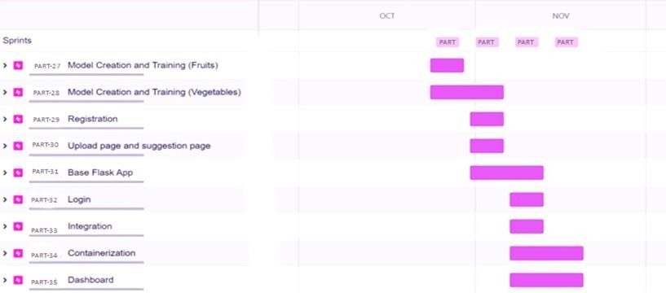

Screenshots:

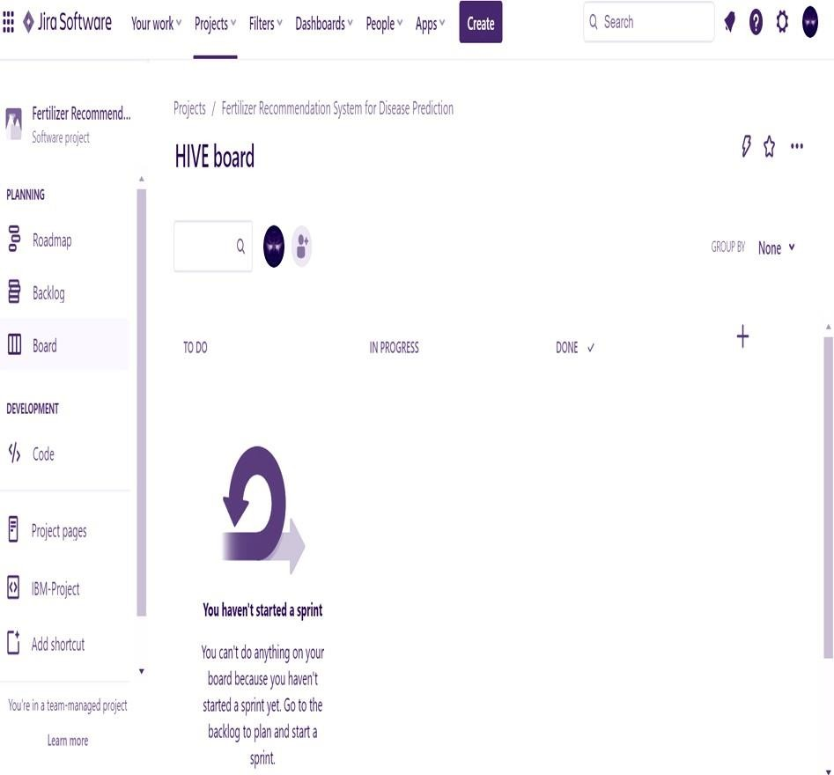

PART Board

